FYI: A one or two liner message that is pertinent to this issue. This template has section headers that have white letters against a black background, the style is Heading 5!”
Any special article that should be on page 1: Any book title or special item should be in italics, i.e. Volunteer Extraordinaire Certificate”, Usually the front page has the details for the next two programs.
Whenever possible, identify source of item or article, i.e. “Byline First name last name.

MONTH, i.e. MAY OR JUNE? PROGRAM

Subtitle, i.e. Annual Picnic.
Date and time span in Arial size 11, bold: Text of all articles should be Times New roman font size 11. Program information should include info to register, for example “email ???@vipclubmn.org before due date, i.e. October 30th for a chair/table reservation and a pre-printed name-tag.”
Include an icon or photo to grab reader’s eye, for example this has been used for the Roseville good old days in May.
Byline Coordinator name in Ar Blanca font size 11

PRESIDENT’S MESSAGE
Main theme of President’s message – Keep photo near top
President’s message should be last thing to go in after he/she has read draft of newsletter just in case there are items to be emphasized.
The chief editor will use yellow highligting in drafts to flag areas subject to changes.
Underline secondary President’s message topic. plea –
Harvey Taipale, VIP Club President.

MONTH, I.E. May or June PROGRAM

Subtitle of next event!
Month date 5th, 11 AM – 2:30 PM. A location icon and driving directions is good for those who do not use GPS, for example
Driving Directions: Set your GPS to St Paul, 2750 Sibley Memorial Hwy, 55121 or take exit #98 off I35E onto Lone Oak Road. Go west across Pilot Knob Road and then down the hill to Hwy 13. Turn right and proceed north ~ ½ mile to the Lost Spur (City View) entrance on the right. Coordinator is Paul Hove
We want the readers to know whom to contact.

WELCOME NEW MEMBER(s)
List new member names, city, and retired from organization. This info usually comes from the membership chair or can be extracted from the most recent database.

OTHER UPCOMING ACTIVITIES

List the next two VIP Club Board Meeting dates, place, and time.
List dates of upcoming events that are scheduled: Do not include the one or two programs that are expounded upon in the Front or 2nd page near term items.
Any photos or icons included should be aligned left or right or center – don’t let them float! Else they tend to jump when the docu-tech or pdf system does a ‘print.’
Use a Column Break to make reading easier, i.e. new section atop next page or right column

SOCIAL REPORTS & ARTICLES

A brief report about an event that recently happened Letters to the editor or any non-legacy articles submitted by board members or club members.
If embedding a link for on-line readers, verify that it works in both the .docx and .pdf images before going to press. (http://vipclubmn.org/History.html#Officers) We do not want to have our readers encountering this message.
Next topic: The chief editor is welcome to do what she/he is most comfortable doing!
If including photos with an article, identify the people unless it is a crowd photo, an example:
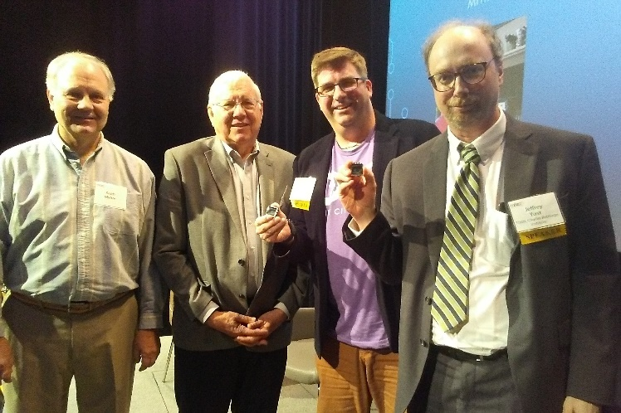
Keith Myhre and Harvey Taipale presented ERA lapel pins to Kevin Dragseth and Dr. Jeffrey Yost.

IN REMEMBRANCE OF

The obits hereunder are redacted from funeral home postings or Pioneer Press or Star Tribune listings.
Last Name, First – Age 69 of town. He is survived by wife of …… She/he worked at …. He/she was a VIP Club member if in the database – whether active or inactive member of the Club. If not in the database, don’t mention the Club. The obits in any issue should be in alphabetical order.
If a photo is included, align it either right or left for alternate obits
Submitted by Person who sent obit to editor.

LEGACY TIDBITS
Catchy Title?
Note that subtitles within a section have a 4-pt space above the line and a 4-pt space after the byline.
Even though I’ve decided to take a 2020 sabbatical from volunteerism – I may be available for a phone chat about how to fix a problem with either the newsletter layouts or the website. Byline LABenson

CLUB CONTACT DATA
This section is considered to be boiler plate. It could be moved to various places within the newsletter to minimize white space when doing the final pagination. Note that board member phone numbers are on the back page. Phone numbers continue to be important because all members do not have email addresses.
VIP Club 2020 Activity Coordination:
CBI Liaison; Dick Lundgren, rflundgr@aol.com
Golf Leagues; Keith Behnke, keithbhnk@comcast.net
Lawshe Museum Support;
- Exhibits; Keith Myhre kmyhre@lightblast.net
- Photo ID work; Bob Pagac rpagac@hotmail.com and Jon Simon jcsimon1st@frontiernet.net
Legacy Committee chairman; John Westergren, jwestergren48@gmail.com
Membership database; Gish Devlaminck membership@vipclubmn.org
Old Timers’ Annual Reunion; paul@paulhove.com or steve.koltes@comcast.com,
Picnic planning & volunteer staffing; John Westergren, jwestergren48@gmail.com
Roseville Good Old Days; Paul Dickson paul.dickson@comcast.net
Syttende Mai: Dale Torgerson, dale.o.torgerson@gmail.com
Sunshine Cards; Lynn Lindholm lynnlindholm@comcast.net
UNIHOGS & Technologists; board@vipclubmn.org
Volunteer Luncheon; Frank King, kingx063@umn.edu
Webmaster; Jim Andrews, webmaster@vipclubmn.org
Retirement Status and Benefits:
Numbers to call if you or your heirs have death benefit or pension questions – you will need an SSN and a PIN.
Unisys 1-877-864-7972
Lockheed Martin 1-866-562-2363
This retirement status box can be moved about within the newsletter if needed to minimize white space while doing the final pagination.
This is another column break point.

😊 LIGHTER SIDE 😊

- Aspire to inspire before you expire.
The quantity of items to be included in this section are expanded or deleted in order to finish the newsletter with exactly 8 or 6 or 4 pages. Paragraph alignments should be justified, for bulleted items left alignment. Align captions as centered.
Quick Quips can be included in a box! If white space filler is needed, use more than one box.
The penultimate page usually has a section break to change from two columns to full width to facilitate inclusion of page wide forms and/or collages.
When adjusting the amount of lighter side to use, make sure that forms do not break across a page. use mine.

Clip here - - - - - - - - - - - - - Clip here - - - - - - - - - - Clip here - -

MEMBERSHIP APPLICATION or RENEWAL or CHANGE FORM
Please mark an X in the appropriate info/option boxes. Submittal Date: ___________
Dues: □$7.00 1-year, or □$ 18.00 3-years, or □free if age 90 or older.
□Renewal, □New Member (>55), □Associate member (<55), □Life (>89), or □Information Change.
________________________________________________ ____________________________
Name (Last, First, M.I. – or attach an address label.) Spouse’s Name
________________________________ ________________________ ____ ___________
Street Address or P.O. Box City State Zip Code
(_____) _______-____________ ________________________________________________
Primary Telephone Number E-mail address
Newsletter delivery default is □ electronic or select □ U.S. Mail if you have no email address.
Employer is/was □UNISYS, □Lockheed Martin, and/or □predecessor company ___________________.
Include me in the Club’s Directory? □Yes or □No. DIRECTORY is only available to Members and Associates!
MAIL FORM WITH CHECK* TO: VIP Club - Membership P.O. Box 21903 Eagan, MN 55121
*not required if only changing information in our database or if renewing at age 90⁺.

Example of a page wide collage from an event.

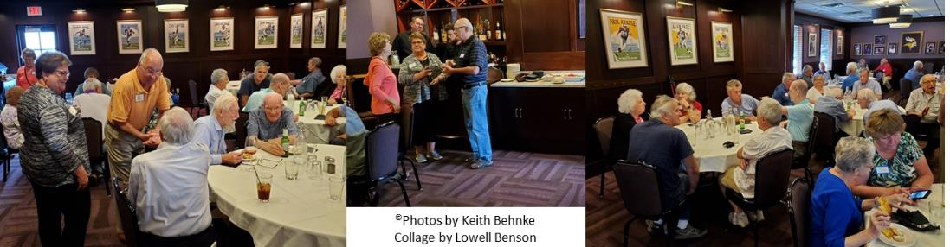

There should always be a page break before the last page because the Docu-tech machine prints addresses and membership expiration date thereon.
P.O. BOX 21903
Eagan MN 55121

Note that these two boxes are ‘Boiler Plate’, i.e. should be verified before the January and July issues!

VIP CLUB Newsletter
P.O. Box 21903, Eagan, MN 55121
http://www.vipclubmn.org/Newsletters.html
Board of Directors - 2020
President Harvey Taipale 651-280-7332
Vice President Steve Koltes 651-303-9112
Treasurer Paul Hove 651-738-4908
Secretary Boni Westberg 651-429-2534
Director Dick Lundgren 952-288-5141
Director Gish Devlaminck 651-470-8905
Director Jim Andrews, 651-451-7502
Director tbd ??? xxx-yyy-zzz
Past President Keith Behnke 651-894-2182
Newsletter Editorial Staff
Chief Editor newsletter@vipclubmn.org
Dick Lundgren rflundgr@aol.com
Don Naaktgeboren donfishn@yahoo.com
Joe Schwarz jschwarzsr@centurylink.net
UNISYS Liaison
Kirsten Rasmussen; meetings, etc., 651-323-9543
Judy Bornetun; Eagan print shop, 651-635-6792

PERIODIC SOCIAL GROUPS
Monthly Breakfast Gathering
- 1st Thursday at 8 AM at the Capitol View Cafe, 637 Smith Ave. St. Paul.
Monthly Lunch Gatherings
- 1st Tuesday in Eagan at 11:00 AM - Rickey's Café at Stark's, 3125 Dodd Road, Eagan, MN
- 2nd Tuesday at 11:30 AM - Mall of America 3rd floor North Food Court, we meet by the tables between the elevator & Burger King. Coordinator, Paul Wennerstrom, 952-854-7855.
- 2nd Wednesday at 11 AM at Baker’s Square, Northtown, 221 Co. Rd. 10 NE, Blaine MN.
- 2nd Saturday of odd numbered months at 11:00 AM, Baker's Square, 1881 West Highway 36, Roseville. Coordinator Urho Rahkola, 651-429-3319.
Quarterly Breakfast Gathering
- 2nd Wednesday at 9 AM in the Eagles Club, Old Hwy 8, in New Brighton., Mar., June, Sept., & Dec. Coordinator Marv Brown, 763-416-3903

